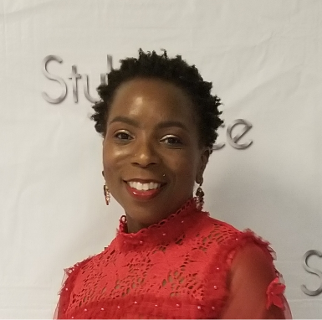
Paula Anne Smith-Benson, Major, United Stated Air Force (Retired), currently resides in Philadelphia, PA after over 20 years of honorable service to our country. She is also a Registered Nurse with over thirty years of women’s health expertise. She is a survivor of Military Sexual Trauma and Intimate Partner Violence. She has turned her pain into passion and surviving into thriving and now is dedicated to supporting other survivors in finding and fulfilling their purpose. She is a Certified Trauma Recovery Coach and Professional Christian Life Coach and serves as the Executive Director of the Women Veterans Command Center in Philadelphia, PA.

In 1989, Major Smith-Benson obtained her direct commissioning in the United States Air Force Nurse Corp as a Second Lieutenant after earning her Bachelor of Science degree in Nursing from Hampton University in Hampton, Virginia. In 1996 she earned a Master of Science in Nursing, specializing in Nurse Midwifery from the University of Alabama at Birmingham in Birmingham, AL. Immediately following graduation she received Board Certification as a Certified Nurse Midwife. She is currently pursuing a Doctor of Management in Strategic Leadership and a Doctor of Philosophy in Complex Systems Leadership from Jefferson University.

